A000-US-TN-Mississippian Pot-Human Effigy-Female-900 CE

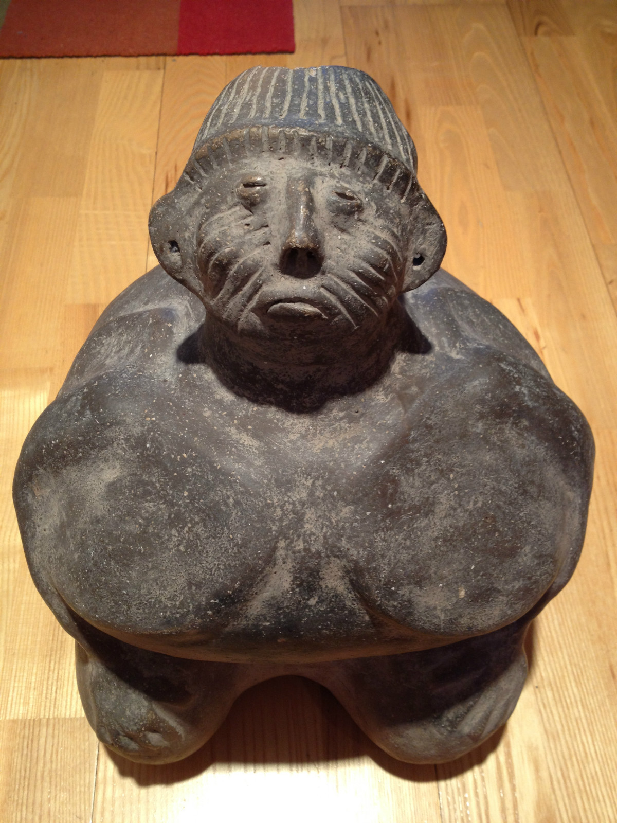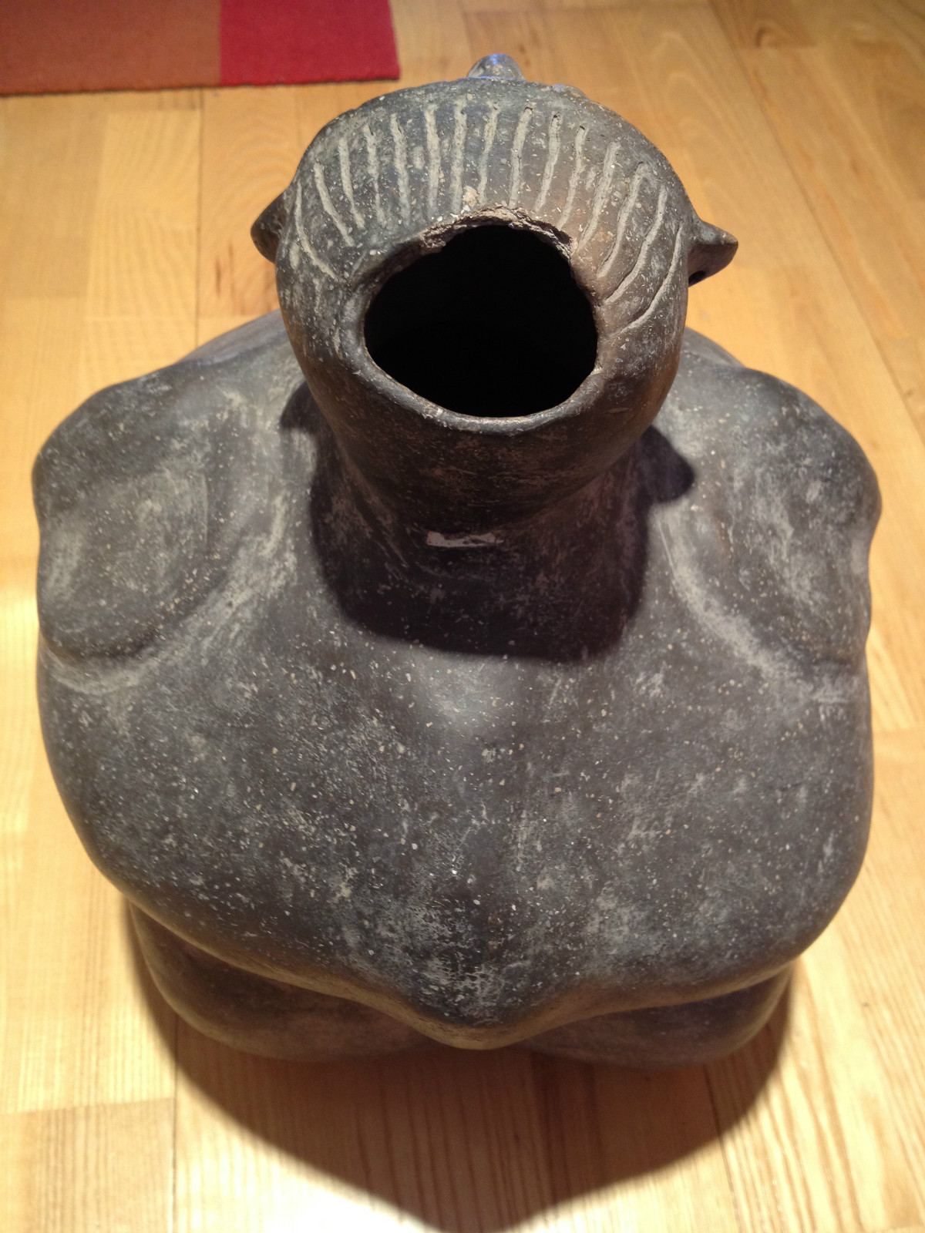

US-TN-Mississippian-Pot-Human Effigy-Femal-900 CE

Case No.: 12

**Accession No.**

**Formal Label:** US-TN-Mississippian-Pot-Human Effigy-Femal-900 CE

**Display Description:**

Mississippian human effigy pot, woven headdress, scarifications on face, ca. 100-1300 CE,



A similar effigy pot was found at Hales Point, TN, (8.75 x 6.75 in, Moore 1916:496).

Keven E. Smith identified two different types of “Flint-Clay” statues in the Tennessee-Cumberland region: the Ancestral Pair and the Old Woman (or Corn Mother or Earth Mother or Old Woman Who Never Dies [a Mandan-Hidatsa figure]) of which this statuary may be an example of the latter (Smith 2009:31). The Old Woman is a complex mythological figure that has its origins in the central Mississippian culture that is known because the flint-clay of many of these figurines has been sourced to the Cahokia area (Emerson 1982, 1985, 1995, 1997; Emerson and Hughes 2000, Emerson et al. 2003). Therefore, the recovery of this ceramic statuary of Old Woman from Hale’s Point, Tennessee, indicates that it is a product of diffusion from the core area of Cahokia. Hale’s Point, now destroyed by river flooding, is famous for having belonged to a group of western TN late Mississippian sites with urn burials of a rectangular shape (Thurston 1890:29-31). This ceramic may have been associated with one of these burials.

**LC Classification:** E99.M6815

**Date or Time Horizon: 900 CE**

**Geographical Area:** possibly near Hales Point, TN

**Map: after** Moore 1916.



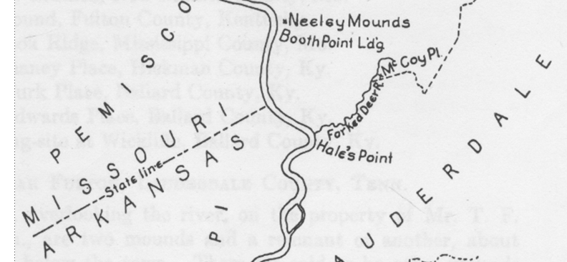

From **Moore 1916.**

**GPS coordinates:**

**Cultural Affiliation:**

**Medium: clay**

**Dimensions:** 13.5 inches high by 11 inches wide and 11 inches deep.

**Weight:**

**Condition: original**

**Provenance:**

**Discussion:**

**References:**

Beckwith, Martha Warren. 1932. *Myths and Ceremonies of the Mandan and Hidatsa*. Vol. 2. Vassar College, New York.

Beckwith, Martha Warren. 1938. Mandan-Hidatsa Myths and Ceremonies. *The American Folk-Lore Society*. J. J. Augustin, New York.

Emerson, Thomas E. 1982 *Mississippian Stone Images in Illinois*. Urbana: Illinois Archaeological Survey Circular 6.

Emerson, Thomas E. 1989. Water, Serpents, and the Underworld: An Exploration into Cahokia Symbolism. In *The* *Southeastern Ceremonial Complex: Artifacts and Analysis*. P. Galloway, ed. Pp. 45-92. Lincoln: University of Nebraska Press.

Emerson, Thomas E. 1997. *Cahokia and the Archaeology of Power*. University of Alabama Press, Tuscaloosa.

Emerson, Thomas E., and Steven L. Boles. 2010. Contextualizing Flint Clay Cahokia Figures at the East St. Louis Mound Center. *Illinois Archaeological Survey* 22(2):473-490.

Emerson, Thomas E., and Randall E. Hughes. 2000. Figurines, Flint Clay Sourcing, the Ozark Highlands, and Cahokian Acquisition. *American Antiquity* 65:79-101.

Emerson, Thomas E., and Douglas K. Jackson. 1984. *The BBB Motor Site*. Urbana: University of Illinois Press.

Emerson, Thomas E., Randall E. Hughes, Mary R. Hynes, and Sarah U. Wisseman. 2002 Implications of Sourcing Cahokia-Style Flint Clay Figures in the American Bottom and the Upper Mississippi River Valley. *Midcontinental Journal of Archaeology* 27(2):309-338.

Emerson, Thomas E., Randall E. Hughes, Mary R. Hynes, and Sarah U. Wisseman. 2003. The Sourcing and Interpretation of Cahokia-Style Figurines in the Trans-Mississippi South and Southeast. *American Antiquity* 68(2):287-313.

Keller, W.D. 1968. Flint Clay and a Flint-Clay Facies, *Clays and Clay Minerals*, 1968, Vol. 16, pp. 113-128. Pergamon Press.

Moore, Clarence B. 1019. *Some Aboriginal Sites on Green River Kentucky, Certain Aboriginal Sites on Lower Ohio River, Additional Investigation on Mississippi River*, Reprinted from the Journal of the Academy of Natural Sciences, Philadelphia, Vol. XVI. Philadelphia.

**Appendix:** additional views

